, 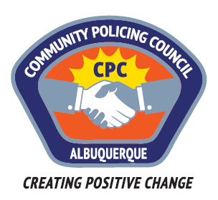

Valley Area Command Community Policing Council

AGENDA

July 27, 2017

APD Training Center
5412 Second St. NW
Albuquerque, NM

6:00pm Call to Order
Determination of a Quorum
Approve Agenda
Approve June 22, 2017, Meeting Minutes

6:15pm Presentation by Police Service Aide Instructor, Larry Edmondson

7:00pm Public Comments and questions for the police regarding the rise
in crime in our Neighborhoods. Discussion about creating a
recommendation relating to the problem as a whole.

8:00pm Meeting Adjourned

Next Meeting: August 24, 2017

